To implement a cache with eviction, we need the following features:
- Add items to the cache (put operation).
- Retrieve items from the cache (get operation).
- Automatically evict items based on a policy when the cache reaches its capacity.

Eviction Policies
Common eviction policies include:
- Least Recently Used (LRU):
  - Evicts the least recently accessed item.
- Least Frequently Used (LFU):
  - Evicts the least frequently accessed item.
- First-In-First-Out (FIFO):
  - Evicts the item that was added earliest.

Below is an example implementation of an LRU Cache.

Java Implementation: LRU Cache

Using a LinkedHashMap
LinkedHashMap provides a straightforward way to implement an LRU cache by overriding its removeEldestEntry method.
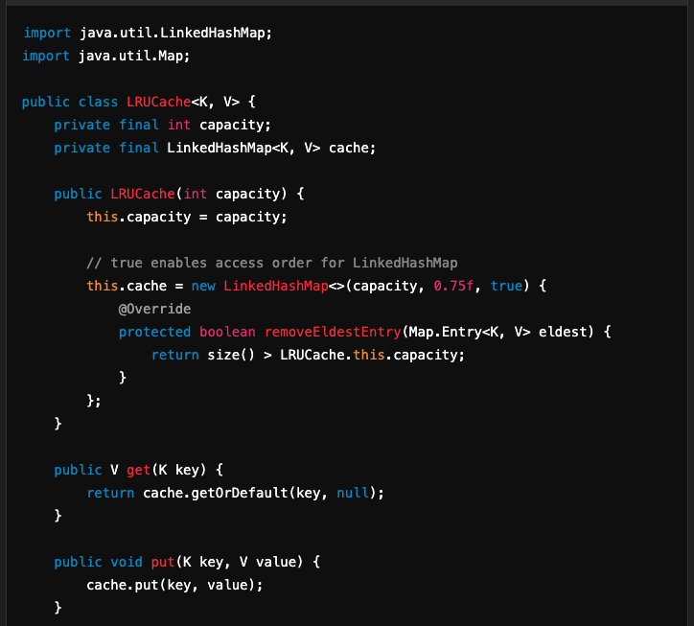
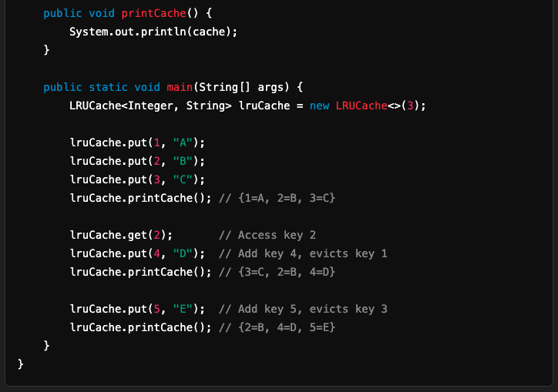

Explanation of LinkedHashMap Implementation
- Access Order:
  - LinkedHashMap maintains the order of elements based on access (if the accessOrder parameter is true).
- Eviction:
  - The removeEldestEntry method determines when the oldest entry should be removed. In this case, it's removed when the cache size exceeds the capacity.

Custom LRU Cache Implementation
If you want to avoid using LinkedHashMap, you can implement an LRU cache using:
- A HashMap for O(1) lookups.
- A Doubly Linked List to maintain the order of access.
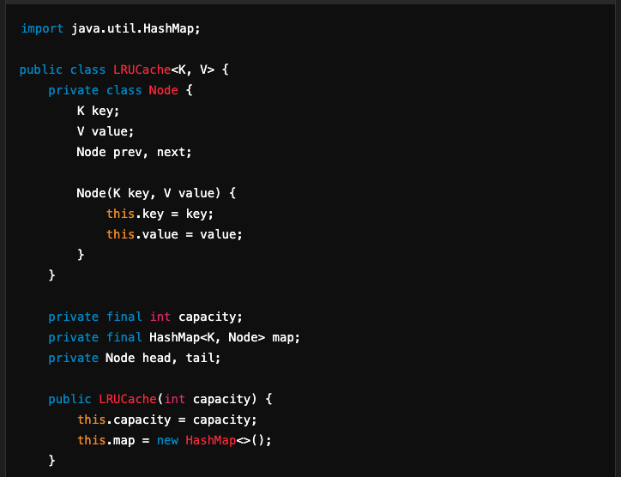
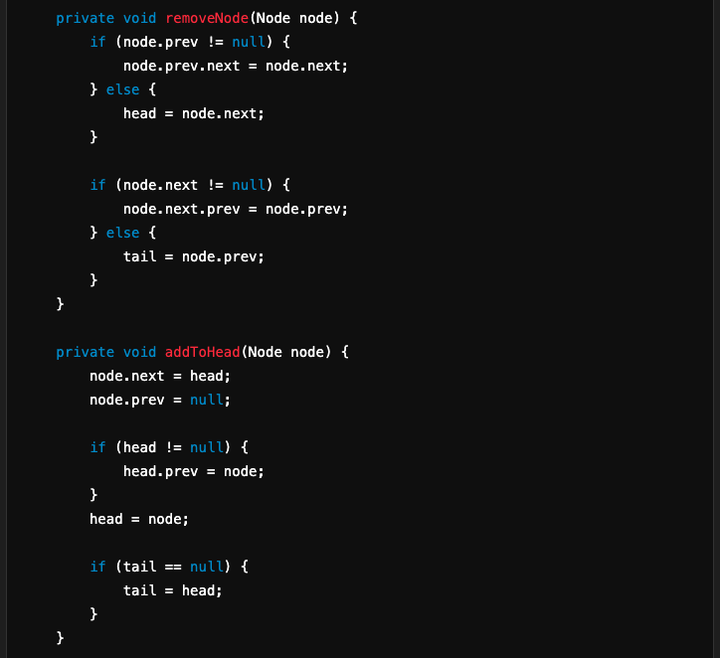
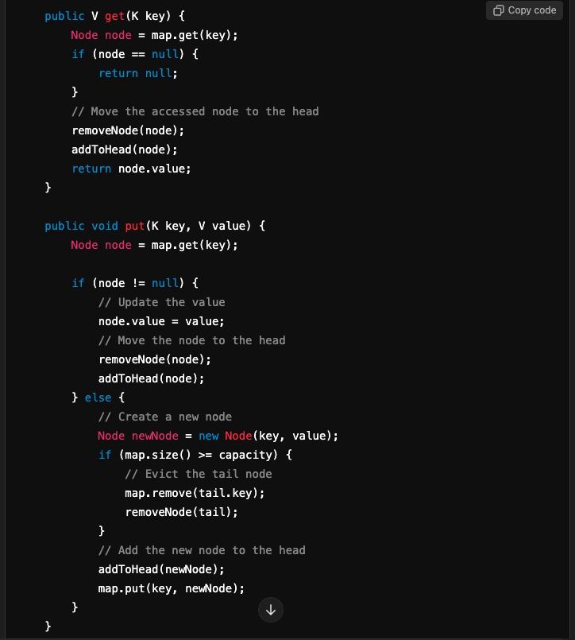
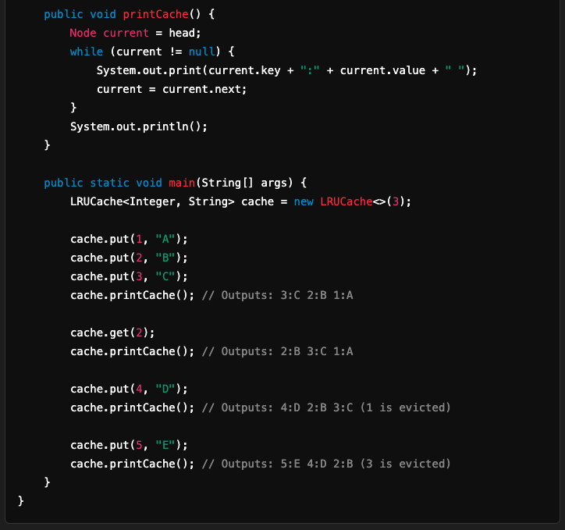

Comparison of Implementations
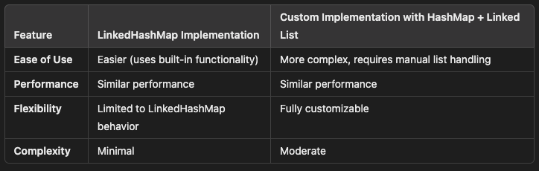

Conclusion
- Use the LinkedHashMap approach if you need a simple and quick solution for an LRU cache.
- Use the HashMap + Doubly Linked List approach if you need full control over the behavior or plan to implement custom eviction policies like LFU or FIFO.

